

Welcome to 'A Sister's Circle'
Where insights, stories, and scripture enlighten and inspire our journey.
This month's edition is rich with insights and support, featuring a courageous testimonial from a survivor whose voice echoes strength across our community. Dive into our latest blog to understand the complex reasons why people may stay in abusive relationships. We also share an inspirational Bible verse to uplift your heart, along with the latest updates and opportunities for you to connect and schedule time with our dedicated team. Together, let's continue to weave a tapestry of hope and healing.
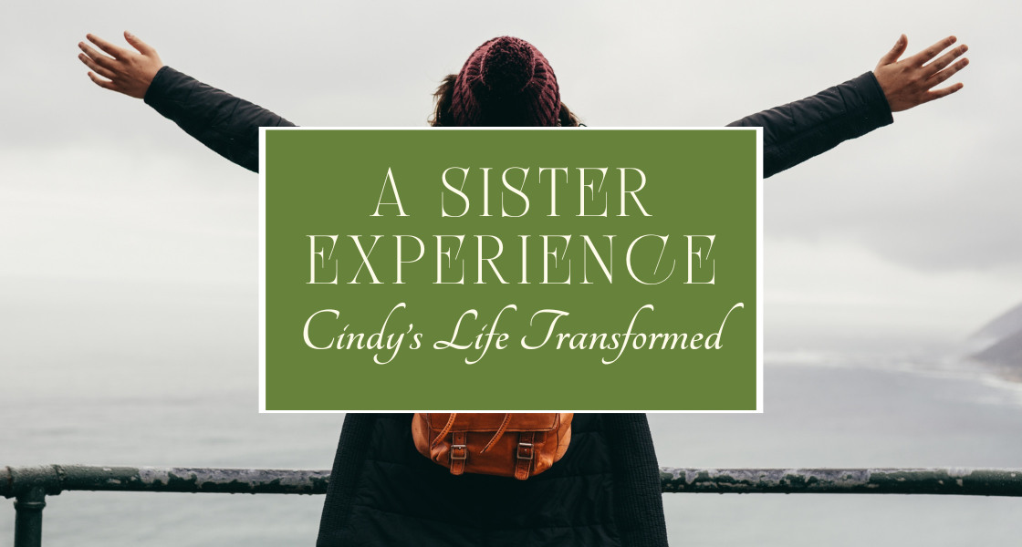
A Sister Experience
Read Cindy's Firsthand Powerful Journey of Transformation and Discover How Hagar's Sisters Support Helped Along the Way.
"I met my husband when I was 13. We married young, eventually raising eight wonderful children together. But now, looking back, I can see that the abuse had started even in those early years—controlling behavior, isolation, and angry explosions. I tried to change myself, believing that if I did everything right, I could prevent the next explosion. Over time, however, the abuse grew more intense and violent, no matter what I did. When I sought help from family, friends, and even the church, I was told to work harder, pray more, and submit more fully to my husband. I felt alone and trapped.
In 2021, following an especially brutal attack, I knew I had to leave to save my life and my children’s. Even then, I faced resistance from authorities, who urged me to respect him because of his military service and to not press charges.
We finally separated but I was broken and desperately needed help. That’s when I found Hagar’s Sisters, the only group out of about 15 I reached out to that responded to my call for help. They welcomed me with compassion, showing me that abuse was never what God wanted for me. Through their courses, I began to understand what abuse really was and finally believed that it wasn’t my fault. Meeting other women who had been through similar struggles helped me realize that I wasn’t alone.
The Beloved course at Hagar’s Sisters transformed my self-image, allowing me to shed the lies I’d carried for years. God replaced those harmful labels with new words filled with His love and truth.
I felt, for the first time, like I was truly cherished and worthy.
Hagar’s Sisters taught me about boundaries, self-worth, and God’s love in a way that empowered me to start fresh.
Today, God is using my experience to support other survivors. He has given me a beautiful vision to lead groups of women like me at Hagar’s Sisters and also to create a safe haven for women and their children. My young son once said, “Mama, we’re going to help people like us—people whose daddies hurt them.” His words have inspired me to answer the call to serve others on this journey.
Hagar’s Sisters walked alongside me, celebrating my victories and holding me in my pain. I am forever grateful to them and to God, who has restored my life. I am no longer broken but whole, healed, and ready to bring hope to others.
Gratefully,

A Sister from North Carolina"
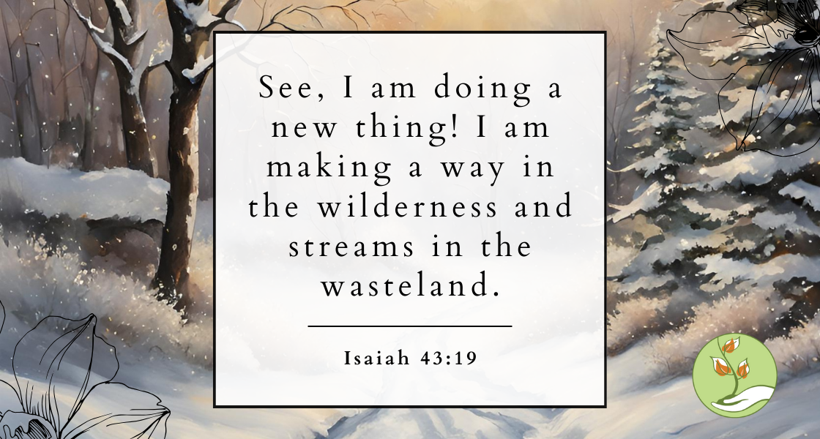
Scriptural Guidance
Verses to Illuminate Your Path
In this month's edition, we bring you a message of renewal and hope inspired by a powerful verse from Isaiah: "See, I am doing a new thing! I am making a way in the wilderness and streams in the wasteland." This quote beautifully highlights the theme of transformative change and divine intervention. As we reflect on these words, let us embrace the new paths and fresh opportunities that lie ahead, trusting that even in our most barren seasons, growth and rejuvenation are possible.
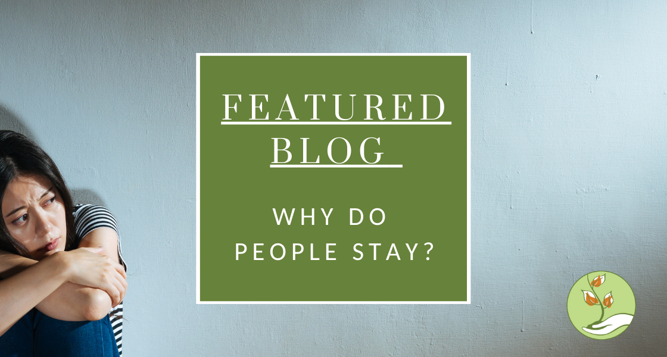
Why Do People Stay in Abusive Relationships?
Understanding the complexities of why some choose to remaining in a harmful environment
If you’re reading this, you might be asking yourself a question that’s both painful and overwhelming: “Why am I still here?” Let us start by saying this—you’re not alone, and it is not your fault. Staying in an abusive relationship doesn’t mean you’re weak or that you deserve what’s happening to you. Abuse is complex, and leaving isn’t as simple as it might seem to others. so why do people stay in abusive relationships?
Let’s explore some of the reasons you might feel stuck—because understanding these feelings is an important step toward healing.
Caught in the Cycle of Abuse
Abusive behaviors often follow a predictable pattern. After an incident of emotional or physical abuse, an abusive partner might apologize, promise to change, or shower you with love and attention. This period of peace can create hope that things will improve. But as the cycle repeats, those moments of peace grow shorter, and the abuse worsens. Recognizing this cycle is important in helping you decide to leave.
Fear Holds You Back
Leaving an abusive relationship often feels dangerous. Many people stay in abusive situations because they fear their partner will retaliate or harm them or their loved ones. These fears are not unfounded—abusers frequently escalate their behavior when they feel their control is slipping. A safety plan can help, and there are resources available to support you through this.
[Click here] to continue reading the full article

